GIT HUB

**Setting Up a Babel Project**

Current browsers don’t support all the new ECMAScript 6 (aka ECMAScript 2015) features yet (see [comptability table](http://kangax.github.io/compat-table/es6/)). You need to use a compiler (transpiler) to transform your ECMAScript 6 code to ECMAScript 5 compatible code. Although there are other options, [Babel](http://babeljs.io/) has become the de-facto standard to compile ECMAScript 6 applications to a version of ECMAScript that can run in current browsers. Babel can also compile other versions of ECMAScript as well as React’s JSX, but that is beyond the scope of this tutorial.

In this unit, you set up a development environment to develop and run an ECMAScript 6 application using Babel.

**Step 1: Install the Sample Application**

1. Clone the [es6-tutorial](https://github.com/ccoenraets/es6-tutorial/) repository that includes an ECMAScript 5 version of the mortgage application we use in this tutorial:
2. git clone https://github.com/ccoenraets/es6-tutorial

Alternatively, you can just download and unzip [**this file**](https://github.com/ccoenraets/es6-tutorial/archive/master.zip) instead of cloning the repository.

1. Open index.html in your browser and click the **Calculate** button.

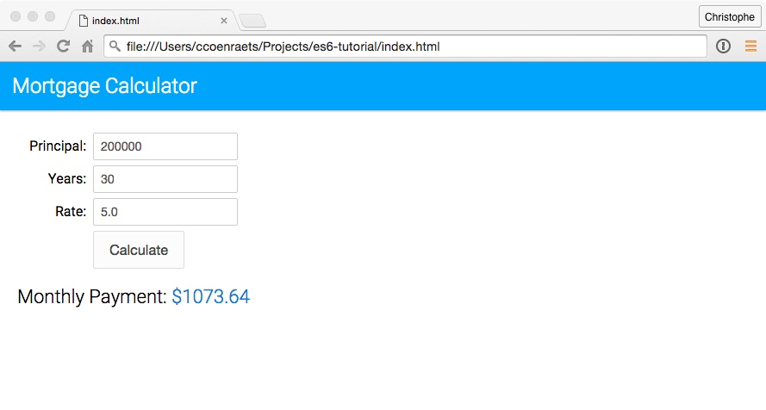

**Step 2: Set Up Babel**

As you just saw, the current version of the application runs in current browsers without compilation: it is written in pure ECMAScript 5. In this section, we set up Babel so that we can start using ECMAScript 6 features in the next unit.

1. Open a command prompt, and navigate (cd) to the es6-tutorial directory.
2. Type the following command to create a package.json file:
3. npm init

Press the **Return** key in response to all the questions to accept the default values.

1. Type the following command to install the **babel-cli** and **babel-core** modules:
2. npm install babel-cli babel-core --save-dev

There are different ways to install and run Babel. For example, you could also install Babel globally and run it from the command line. Refer to the [**Babel**](http://babeljs.io/docs/setup/) documentation for more information.

1. Type the following command to install the **ECMAScript 2015 preset**:
2. npm install babel-preset-es2015 --save-dev

In Babel 6, every transformer is a plugin that can be installed separately. A preset is a group of related plugins. Using a preset, you don’t have to install and update dozens of plugins individually.

1. Install [http-server](https://github.com/indexzero/http-server) in your project. **http-server** is a lightweight web server we use to run the application locally during development.
2. npm install http-server --save-dev

We are using a local web server because some parts of this tutorial require the application to be loaded using the **http** protocol and will not work if loaded using the **file** protocol.

1. Open package.json in your favorite code editor. In the scripts section, remove the **test** script, and add two new scripts: a script named **babel** that compiles main.js to a version of ECMAScript that can run in current browsers, and a script named **start** that starts the local web server. The scripts section should now look like this:
2. "scripts": {
3. "babel": "babel --presets es2015 js/main.js -o build/main.bundle.js",
4. "start": "http-server"
5. },
6. In the es6-tutorial directory, create a build directory to host the compiled version of the application.

**Step 3: Build and Run**

1. On the command line, make sure you are in the es6-tutorial directory, and type the following command to run the **babel** script and compile main.js:
2. npm run babel
3. Open **index.html** in your code editor, and modify the <script> tag as follows to load build/main.bundle.js, the compiled version of js/main.js:
4. <script src="build/main.bundle.js"></script>
5. Open a new command prompt. Navigate (cd) to the es6-tutorial directory, and type the following command to start http-server:
6. npm start

If port 8080 is already in use on your computer, modify the **start** script in package.json and specify a port that is available on your computer. For example:

"scripts": {

"babel": "babel --presets es2015 js/main.js -o build/main.bundle.js",

"start": "http-server -p 9000"

},

1. Open a browser and access [http://localhost:8080](http://localhost:8080/)
2. Click the **Calculate** button to calculate the monthly payment for the mortgage.

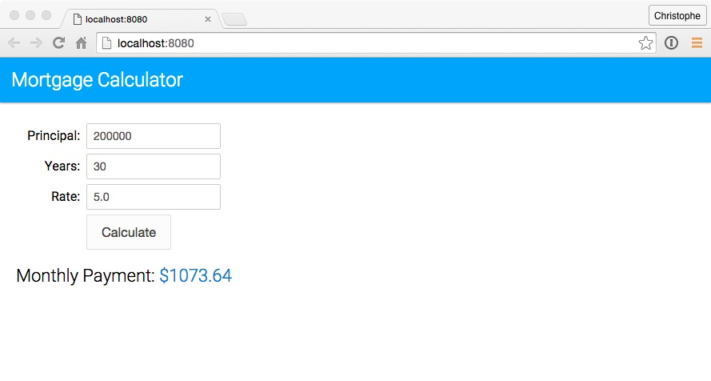

1. Open build/main.bundle.js in your code editor and notice that the generated code is virtually identical to the source code (js/main.js). This is because the current code in main.js doesn’t include any ECMAScript 6 feature. With this setup in place, we are now ready to start using ECMAScript 6 features in the next unit.